Technologies

The Cicret Bracelet: https://www.youtube.com/watch?v=9J7GpVQCfms&feature=player_detailpage
The Future Of Work
Horizon 2020 - How to apply
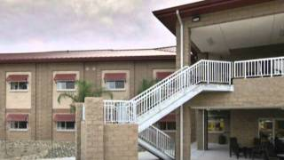 Techniques or Materials Category
Top 5 iphone gadgets you should buy
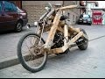When people improvise!
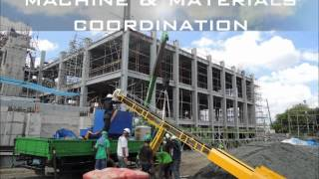 Fast Modern Construction Techniques
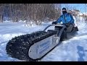 Freeze HD
Things you never knew existed v4
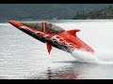 7 Things you never knew existed
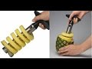 8 Things your kitchen must have
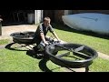New Invention - Hoverbike
Things you never knew existed v5
Things you never knew existed v3
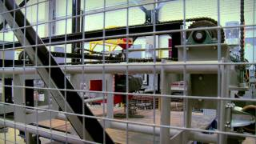 Construction Process: 3D Printing

Horizon 2020 - General overview
https://www.youtube.com/watch?feature=player_detailpage&v=CimJI88c4fE
Europe 2020 strategy
Micro, SMEs
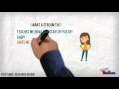Business research process
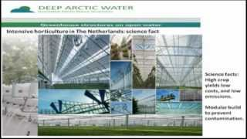Innovative offshore constructions providing multiple layers of farming
Mega Construction Innovation Gaming
SME Funding in Horizon 2020
Bridging business & research
How will be the world in 2020?
"The World in 2030"
Technology In 2019!
Trends inventions & technology for next
EU Standards: Your innovation bridge
Business research process
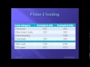Horizon 2020 SME Instrument
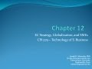E-Commerce, globalization & SMEs
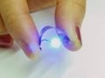Power of Nanotechnology Video

ITC Technologies
Tips for using technology in classroom
The Future of Academic Advising and Technology
Extended Deterrence in Europe/NATO
Technology's empathy gap 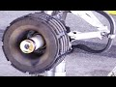Replace Tire on $182 million Doll Plane
ITC -Integrating Technology
ITC - Assistive Technology ITC - Audio-visual Technologies 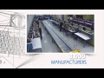 World Wide Technology Capabilities
Technology - learning theories

Agriculture – Horticulture Technologies

Walnut Orchard

TH2500 Pruning Walnuts 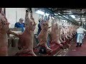 About Sheep processing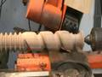 Torspootfrezeni

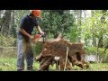 Making a Black walnut table 1/1 RASIP - Vivero
Square watermelons Japan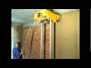 Automatic rendering machine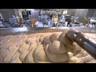 How It's Made - Hot Dogs Stuffed olives
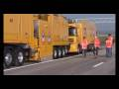 Prototype Wet Weather Shotblasting Machine

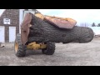 Milling West Bridgewater Walnut Medium Walnut Shelling Plant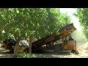How to properly plant walnut trees 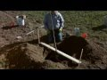Mechanical pruning machine

Automotive Technologies

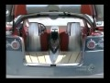 Future of Automotive Technology
The Harvard of Auto Tech 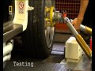 Automotive Engineering

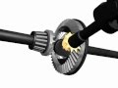How a differential works; differentials
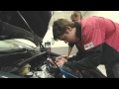 A Career as an Automotive Technician
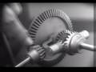 How Differential Gear works
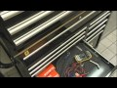 A Career in Automotive Engineering i
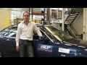 Electromagnetic active suspension system
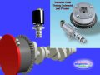 Variable CAM Timing 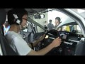Nagoya Univ: Automotive Engineering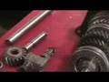 Automotive Technology: Gear Ratios 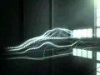Automobile Engineering 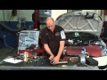 O2 Sensor Diagnostics

Leadership
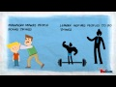 Leaders vs managers
10 Leadership Theories in Five Minutes
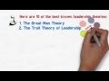 How Good Leaders Become Great
The truth about what motivates us
Leadership Body Language
What is Leadership?
Top 10 Differences Managers-Leaders
What Great Leaders Actually DO
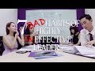Simon Sinek: Why Leaders Eat Last
7 Essential Qualities of Great Leaders
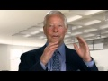 John Maxwell - 5 Levels of Leadership
Social Intelligence and Leadership
Georges Zalucki - Formation Leadership
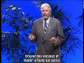 Inspiration - Leadership
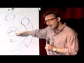 60 Leadership qualities
Why Do We Fall - Motivational Video
Leadership is a Choice
Secrets of Leadership: Churchill

